GENERIC RULEBOOK FOR
Which way to go?
Concept - Design - Development: Upal Mahbub upalmahbub@yahoo.com

Number of Players: 2-8 | Age Limit: 8+ years;
Average Game Play Time: 20 minutes
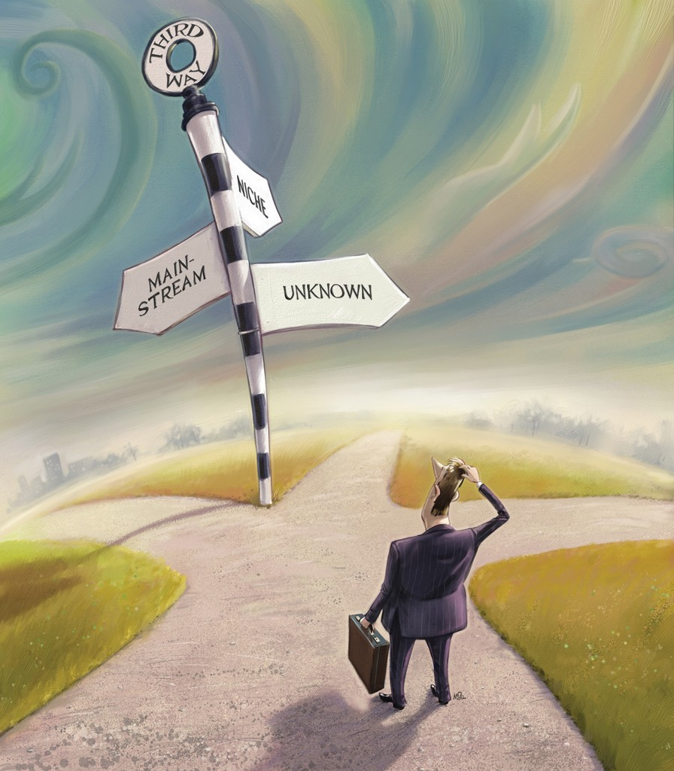
Basic Idea:
In this game each player independently travels from the START node/intersection to the STOP node/intersection using suitable means of transport. The choice of transport may depend on the availability of a particular vehicle and the necessary amount of currency at the player's disposal. The ultimate goal is to maximize the score by traveling faster, saving money, and finishing early. While doing so, each player can create roadblocks and other hazards for the opponents to slow them down in the race. The major components of the game are shown in Fig. 1. Apart from these, each player will have three unique player tokens corresponding to the player’s board color.
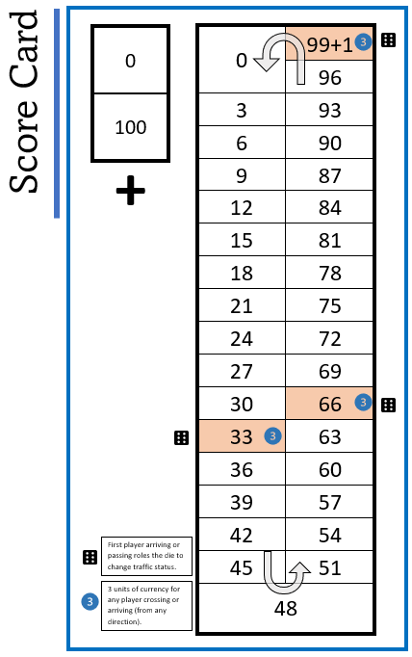
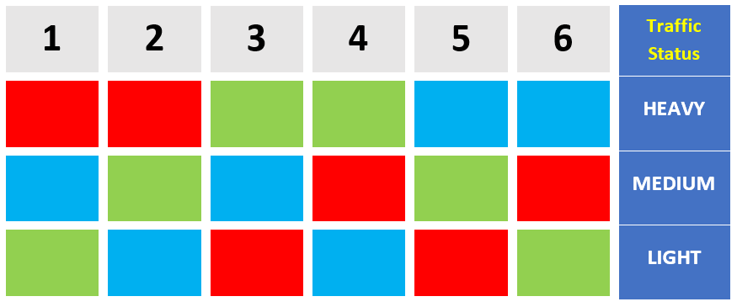
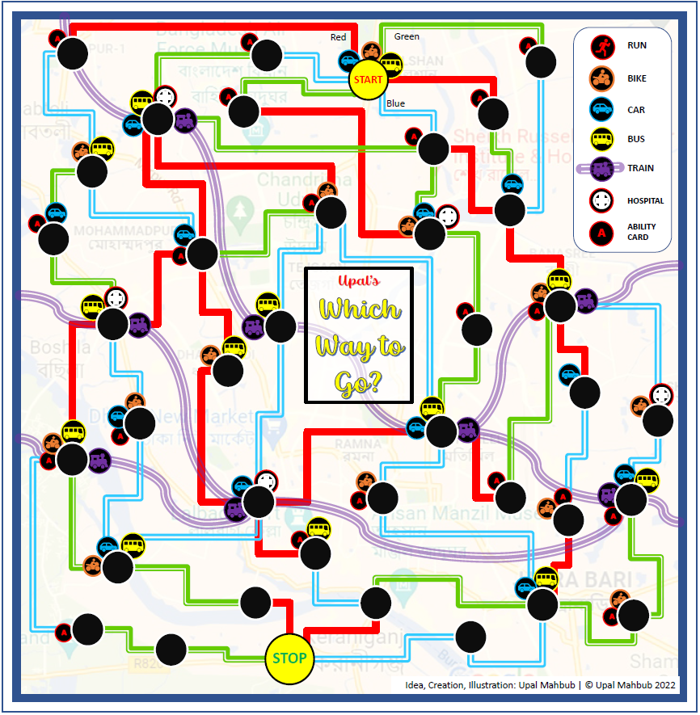
1.
4.

Ability Tround
5.

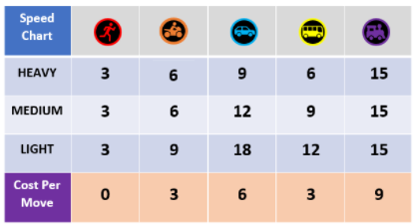
9.
7.
6.

Ability Cards
Pile

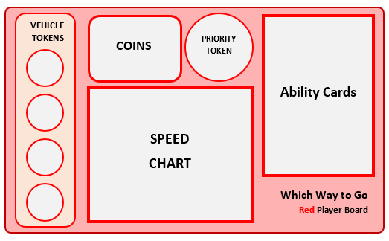
8.



3

3

3
2.

3

3

3
3.

Figure 1: Major components - 1. the board, 2. vehicle tokens, 3. coins, 4. traffic status indicator card and token, 5. ability cards, 6. speed and vehicle cost cards, 7. Round priority token, 8. player board, and 9. the scorecard.
Setup
- The game can be played with 2-8 players.
- The pile of ability cards is shuffled and set face down on the table.
- Each player gets
  - Currency - 12 Units (four money tokens, each worth 3 units)
  - Player board - 1x (the color matches that of the player token)
  - Speed chart - 1x (vehicle speed for different traffic and cost chart)
  - Player tokens - 3x (same color as the player board). The player tokens are placed on the Start location on the map (one token for each player) and the zero positions on the Score Card (two tokens, one on the first row, first column of each table on the score card).
- One of the players gets the priority token. The ABILITY ROUND is skipped because there are no ability cards in the hands of the players. Priority token is set to TRAVEL ROUND and the first player makes a move on the map.
- In the first TRAVEL ROUND all the roads are considered to have MEDIUM TRAFFIC irrespective of the road colors. This is to ensure an unbiased choice of the road for the players without any traffic status prior. Traffic status takes effect from the 2nd round.
  - Note: After the first travel round, roll the dice to determine the traffic conditions. E.g., if the dice roll yields 5 then put the traffic indicator token to the fifth row of the TRAFFIC STATUS CARD (see figure on the right) meaning that blue roads have the lightest traffic, green roads are medium and red roads have heavy traffic.

Gameplay Directions
- Randomly select a player to get the priority token at the beginning of the game.
- After every round, move the priority token to the next player in the same direction as the gameplay.
- The player with the priority token first puts the ABILITY ROUND side up. The ability cards are played starting from the player with the token. In the very first round, no one has any ability card - so there will be no activity in the Ability Round.
- Ability Card Playing Order: The player with the priority token is the first to go followed by the next player in the same order as the priority token movement direction. The ability round ends when all the players are done playing. During his/her turn a player can play as many ability cards as they wish. If he/she possesses any card that states “Play Right Away” or “Play At Once”, those cards MUST be played in the current Ability Round. For the cards saying “Play Once Any Time” the player may choose whether to play those now or save for the future. If a player receives a new ability card as an effect of another ability card just played, he/she may or MUST also play the new ability card depending on the card type.
- Once the Ability Round is over, the first player flips the priority token to TRAVEL ROUND and moves his/her player token on the map followed by the next player's move.
- All players must move at least one node during each round unless prevented (e.g., by roadblocks or an ability card dictating missing a turn).
- The Speed Chart provides information about the cost and speed of each mode of transport under different traffic conditions. The speed of travel is counted as points on the Score Card. Each unit of currency is also converted to an equivalent score at the end of the game. The goal for a player, therefore, is to travel as fast as possible using less money to maximize the overall score in the end.
- If any player uses any vehicle, he/she may get a Vehicle Token for that particular vehicle unless
  - he already has that same token, or
  - his current location already has that vehicle available.
A player cannot hold more than one token of the same vehicle, but he/she may hold multiple vehicle tokens of different vehicles at the same time. For example, a player with a car token may also get a bike token from another player by playing an ability card for stealing a vehicle token.
- If a player does not use a vehicle token at hand in the travel round, he/she has to forfeit the token. E.g., a player with a car and a bike token chooses to walk to the next intersection during the travel round. So, he/she will have to discard both vehicle tokens after the move.
- A player also must forfeit a vehicle token if the same vehicle is available in an intersection. E.g., if a player using a car token reaches an intersection that has a car available the player must discard the car token.
- When traveling by Bus or Train, the player may not change the mode of transport unless
  - A node with a Bus station or a Train Station, respectively, is reached, or
  - If the player token is moved unexpectedly from the course by an ability card (e.g., call a taxi to go to the nearest train station, or, an accident resulting in a move to the nearest hospital).
If a player cannot pay the ticket prices for the remaining rides, 6 points (for BUS) or 24 points (for Train) will be deducted from his/her score card for every node traveled without pay.
- Players must pick two ability cards from the pile whenever they reach an intersection with the ability card symbol  - keep one and discard the other.
- If a player declares an ability during the Ability Round but fails to play it, he/she has to forfeit the ability card. E.g., a player declares the intention to run at 12 mph in a turn, however, another player uses an ability card to block all the roads that the first player can use to travel. In this case, the first player has to discard the ability card during the travel round and will basically miss a turn.
- Bonuses and Penalties:
  - Fastest player bonus - minimum steps to finish - 15 pts
  - Money bonus: All the leftover money from the player becomes equivalent points at the end. E.g., a player has three 3 unit coins at the end of the game means he/she will score an additional 9 points on the Score Card.
  - Extra step penalty: Once a player reaches the finish line, find the shortest path to finish for all the other players and deduce 6 points per intersection to reach the finish from the score in the Score Card.
- The player with the highest score, after considering all bonuses, penalties, and travel scores into account, wins.
- Tiebreaking rules: If two or more players have the same score after counting everything the player who is closer to the stop (got less penalty) wins. If the players are still tied, the player with more money wins. If the players are still indistinguishable, please play another round to find the winner :)

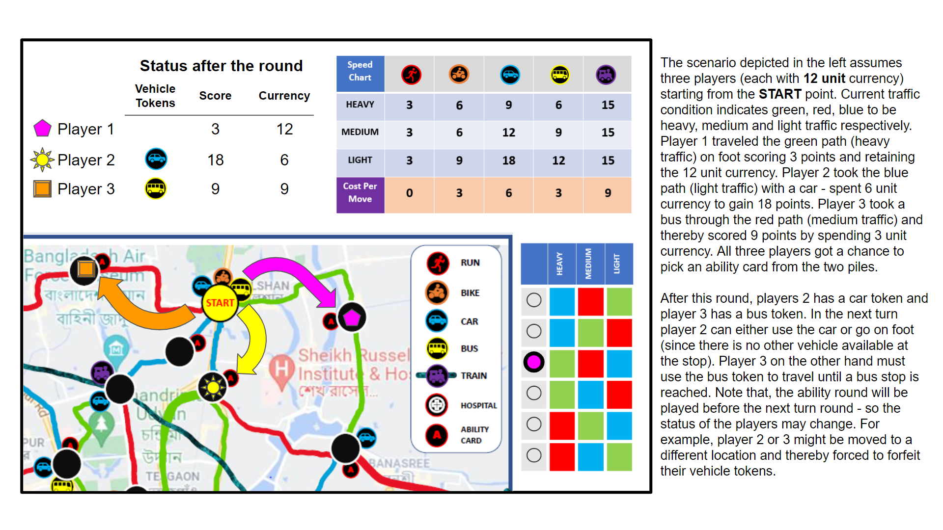
GAMEPLAY EXAMPLE: Sample turn showing currency and score calculation
Components in Detail

- Map:
Each road segment (between any two intersections) is one unit of road. Each map (expansions may include more than one map) will have a START or teleport In node and a STOP or teleport out node. The common goal for all players is to go from the starting node to the end node with a minimum number of turns while maximizing their points and money.

- Symbols on the map
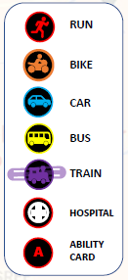

- Traffic Status indicator
There are roads and train lines (Future expansion: metro rail/subway, waterways, and airways - multiple boards for different cities - option to teleport from one map to another, etc.). Each road is color-coded with red, green, and blue. Railroads are separately drawn and are not subjected to traffic.

Interpretation of the color codes may change during gameplay. The color codes will mean heavy, medium, and light traffic. The traffic indicator card is shown on the right. Roll a dice at the beginning of a game to determine the initial traffic condition. If a road is blocked, put a roadblock marker (X) on that color in the current traffic indicator row.

- Vehicles
The vehicles include bikes, cars, buses, and trains (In other modifications or expansions there might be bicycles, rickshaws, scooters, boats, airplanes, etc.). Each vehicle can go at different velocities for different traffic conditions.

By default, a player can walk from one intersection to another connected with a road (not railways). Alternatively, the players can take a vehicle (if available in an intersection or if the player already holds a vehicle token). If a player takes a vehicle to travel from one intersection to another, he gets a Vehicle Token for that vehicle. Every intersection has an unlimited supply of vehicles that are available there. So, any number of players can take the same vehicle at an intersection.

A player cannot hold two tokens of the same vehicle at a given time. Also, if the player reaches an intersection where the same vehicle is available, the player must return the vehicle token.

The Speed chart above shows the points a player earns for each vehicle depending on the traffic condition. Different vehicles have different costs to ride. The Cost Per Move row at the bottom of the speed chart shows how much a player has to pay to the bank or central repository to get a ride from a particular vehicle.

SPECIAL RULE for Buses and Trains: For riding on a train or bus one will have to get to the stations (intersection with a train or a bus symbol) and once aboard a player cannot leave a train or bus at any intermediate intersection if a train or bus symbol is not available at that intersection, respectively. If the player runs out of money from riding a train/bus, he will be deducted 6 points for the Bus or 24 points for the Train ride from the Score Card for every additional move without payments. Points will never go below zero.

- Currency
Initially, all players will start with 12 units of currency. Money will be used to ride trains, buses, steamer/boats, taxis, and rickshaws The most common way to get more money is through Ability Cards. Also, for arriving or crossing 33, 66, and 100-point marks on the Score Card at any time, a player may get 3 coins. At the end of the game, each unit of money is worth one point. Note that, each money token is 3 units of currency.

- Ability Cards
Players must pick two ability cards from the pile whenever they reach an intersection with the ability card symbol . VARIATION: Alternatively, there can be two ability card piles, Pile 1 and Pile 2. A player must pick the top cards from both piles.
    - Pile 1 - Cards related to personal advantage/disadvantage. Marked with 1 in the back.
    - Pile 2 - Cards for controlling the game flow. Marked with 2 in the back.

The player must keep one of the two ability cards and discard the other one.

Ability cards can only be played during the ABILITY ROUND at the beginning of any turn. Some are mandatory to play in the next ability round (mentions PLAY AT ONCE / PLAY RIGHT AWAY on the card - e.g. go to the nearest hospital/train station, block all roads of one or two colors, etc.), others can be kept for future usage (mentions PLAY ONCE ANY TIME on the card - e.g. Run at 12 mph, go through a roadblock, etc.).

Whether mandatory or optional, ability cards to be used by a player must be declared at the beginning of a turn. E.g., if a player wants to use ‘Run at 12 mph in a turn, he/she must show and declare that during the ability card turn.

A list of ability cards is given below. Color code - green means this card provides an advantage to the player picking it regardless of the game status; red means this card causes a disadvantage to the player who picked it; blue denotes that the card may go either way (cause advantage or disadvantage) depending on the game status (e.g., the position of the players in the board, traffic status, and availability of currency).

Affecting oneself
    - Run at 9 mph: For this travel turn, the player scores 9 points for running.
    - Get 9 units of currency
    - Go through any roadblock in this turn.
    - Call a taxi to go to the nearest train station
    - Accident - Move to the nearest hospital
    - Driving violation - Miss next turn
    - Move your own player token to the previous intersection
    - Must run this turn and forfeit all vehicle tokens
Affecting one or more other players
    - Get three points from any other player
    - Get a vehicle token from any other player
    - Get an ability card token from any other player.
    - Block a road (including Railroad) for the next turn.
    - Block three roads (including the railroad) for the next turn.
    - Pay 3 units of money to each neighbor
Affecting Everyone
    - Change Traffic status
    - Block all roads of any one color for the next turn
    - Block all roads of any two colors for the next turn
    - All traffic becomes LIGHT for all the other payers for the next turn

Ability card distribution

Card Names | Type | Count
Run at 9 mph | Play Once Any Time | 5
Get 9 unit currency | Play Right Away | 5
Go through any roadblock in this turn | Play Once Any Time | 4
Get three points from any other player | Play Right Away | 4
Get a vehicle token from any other player | Play Once Any Time | 3
Get an ability card token from any other player. | Play Once Any Time | 3
Call a taxi to go to the nearest train station | Play Right Away | 3
Accident - Move to the nearest hospital | Play Right Away | 3
Block a road (including railroad) for this turn | Play Once Any Time | 5
Block three roads (including railroad) for this turn | Play Once Any Time | 3
Block all roads of any two colors for this turn | Play Right Away | 3
Change Traffic status | Play Once Any Time | 4
Block all roads of any one color for this turn | Play Right Away | 5
Driving violation - Miss this turn | Play Right Away | 5
Move own player token to the previous intersection | Play Right Away | 5
Pay 3 units of money to each neighbor | Play Right Away | 4
All traffic become LIGHT for all the other payers for this turn | Play Right Away | 3
Must run this turn and forfeit all vehicle tokens | Play Right Away | 3
Total |  | 70

Special Notes: When taking a taxi to the hospital or getting moved to the nearest train station, the player loses all vehicle tokens. The distance of the nearest bus/train station is counted based on the nodes connected by roads only (i.e., railroads connecting two nodes cannot be considered). The player may choose the destination if there are multiple options at the same distance. The player also gets free from all conditions related to riding the bus or train.

- Player Board
Each player keeps track of their money, vehicle tokens, priority token, and ability cards on a player board. The color of the player board corresponds to the color of the player token.

- Point System
Each unit of money is worth 1 point at the end. Points are tracked on the scorecard. Each player token on the right table of the scorecard is used to count scores from 0 to 100, while player tokens on the left table count the increments by 100s. So the total score at the end of the game would be the sum of the number indicated by the two tokens. The scorecard allows a maximum score of 200 (100 on the first column and 99+1 on the 2nd column). If a player’s score reaches this max, the game stops, and the points are counted following the rules of Bonuses and Penalties described under Points and Winner.

- Points and Winner
Bonuses and Penalties:
  - Fastest player bonus - minimum steps to finish - 15 pts
  - Money bonus: All the leftover money from the player becomes equivalent points at the end. E.g., a player has three 3 unit coins at the end of the game means he/she will score an additional 9 points on the Score Card.
  - Extra step penalty: Once a player reaches the finish line, find the shortest path to finish for all the other players and deduce 6 points per intersection to reach the finish from the score in the Score Card.
The player with the highest score, after considering all bonuses, penalties, and travel scores into account, wins.

Tiebreaking rules: If two or more players have the same score after counting everything the player who is closer to the stop (got less penalty) wins. If the players are still tied, the player with more money wins. If the players are still indistinguishable, please play another round to find the winner :)

